**EXP:1) Create a simple cloud software application for Flight Reservation System using any Cloud Service Provider to demonstrate SaaS include the necessary fields such as one way, round trip, From, to, Departure, Departure, Travelers & Class, Fare Type, International and Domestic Flights etc**

**Procedure:**

STEP1: GOTO ZOHO.COM

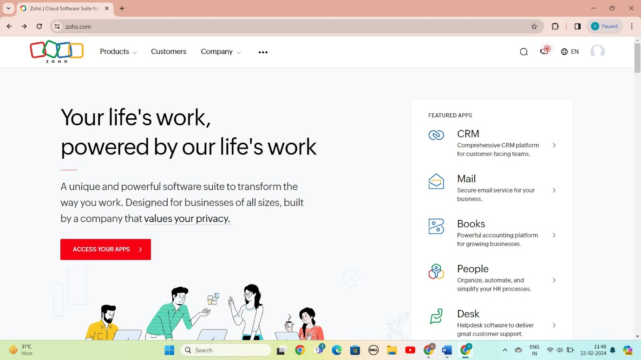

STEP 2: LOGIN TO THE ZOHO.COM

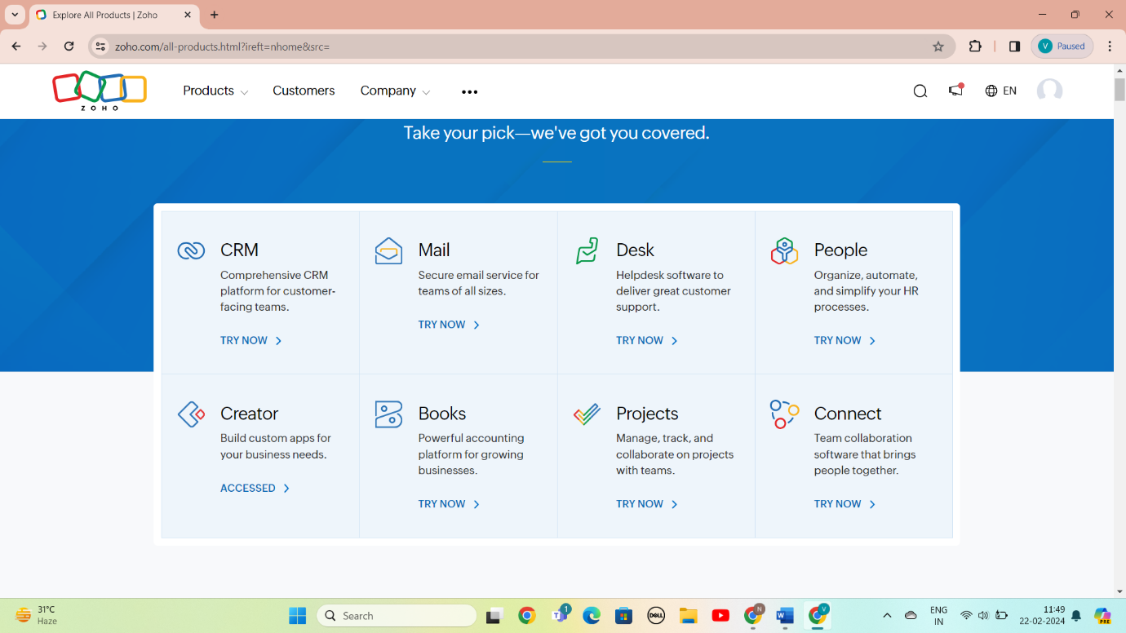

STEP 3: SELECT A CREATE FROM SCRATCH

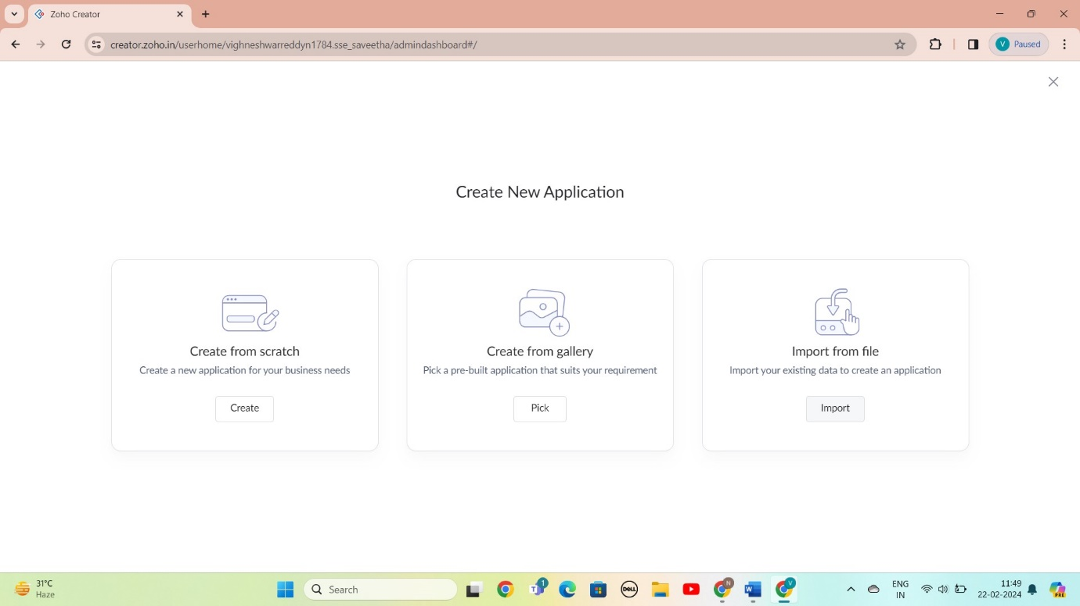

STEP 4: SELECT APPLICATION NAME AS FLIGHT RESERVATION SYSTEM

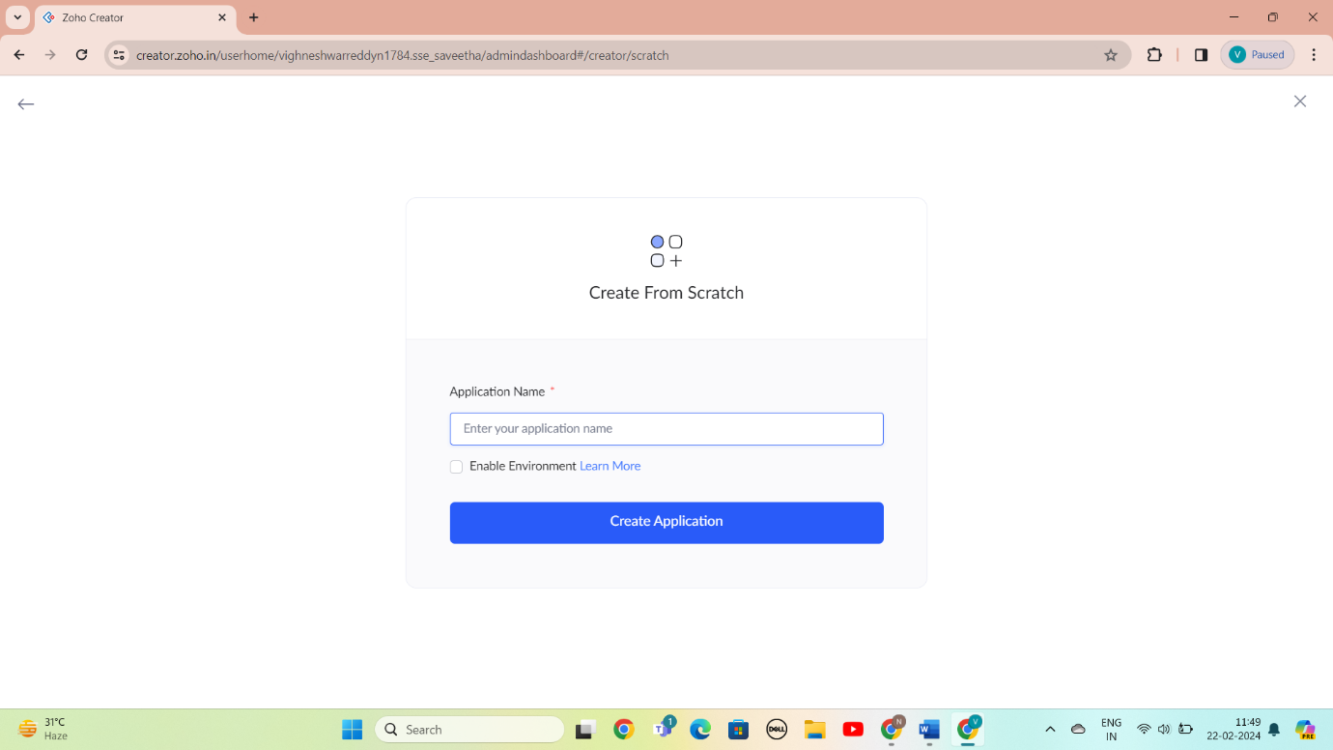

STEP 5: CREATED NEW FORM

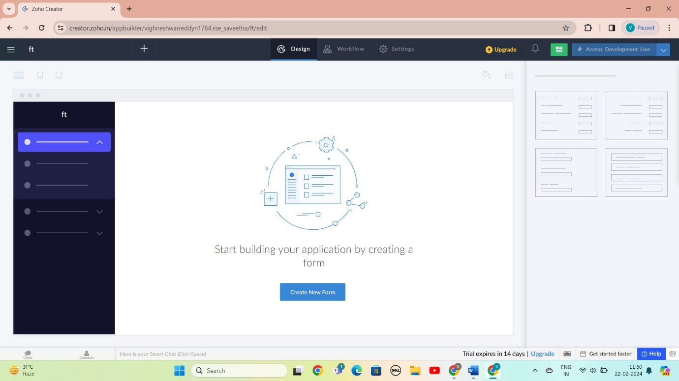

STEP 6: SELECT BASIC FILED FROM GIVEN BELOW AND DEVELOP APPLICATION

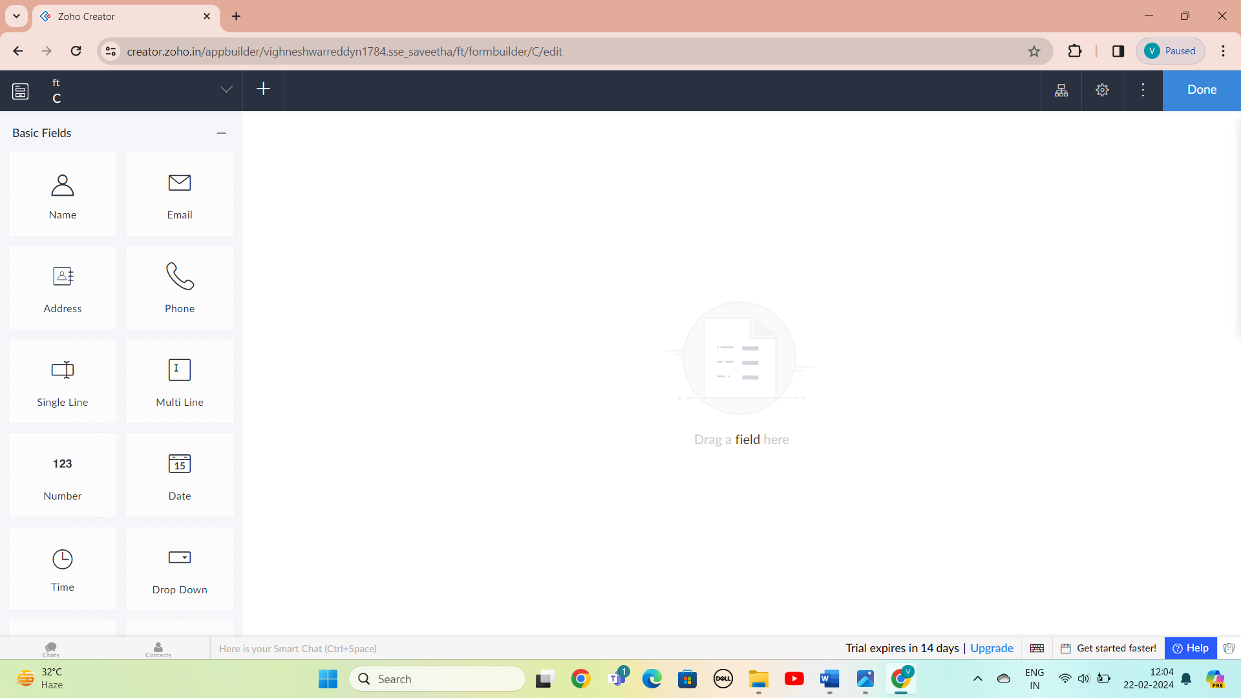

STEP 7: : THE SOFTWARE AS BEEN CREATE LOGIN

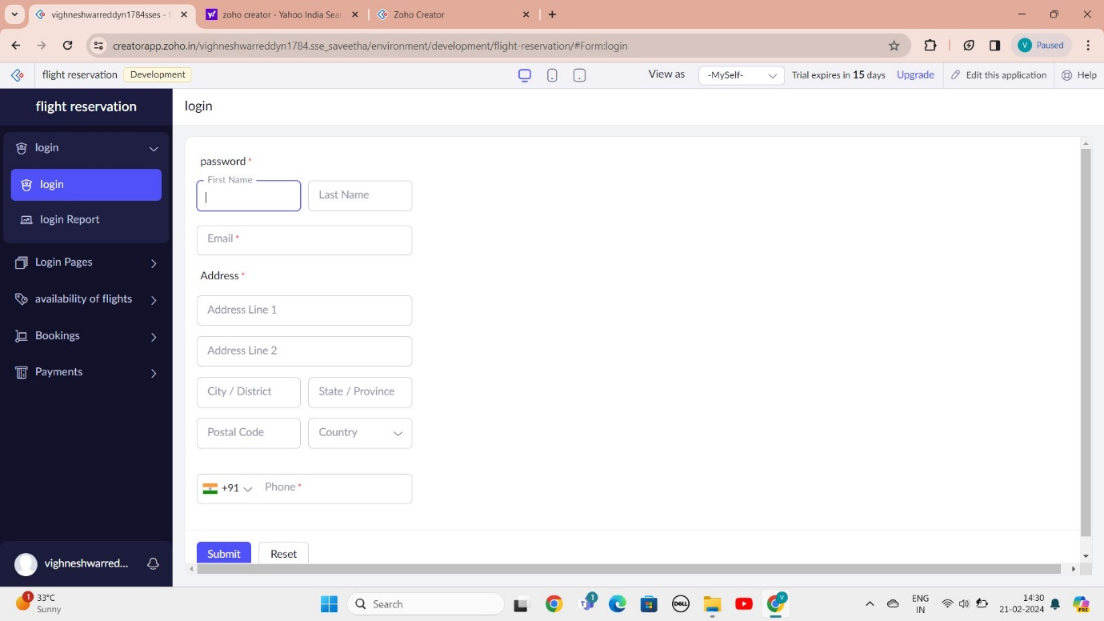

STEP 8: : THE SOFTWARE AS BEEN CREATE LOGIN PAGE

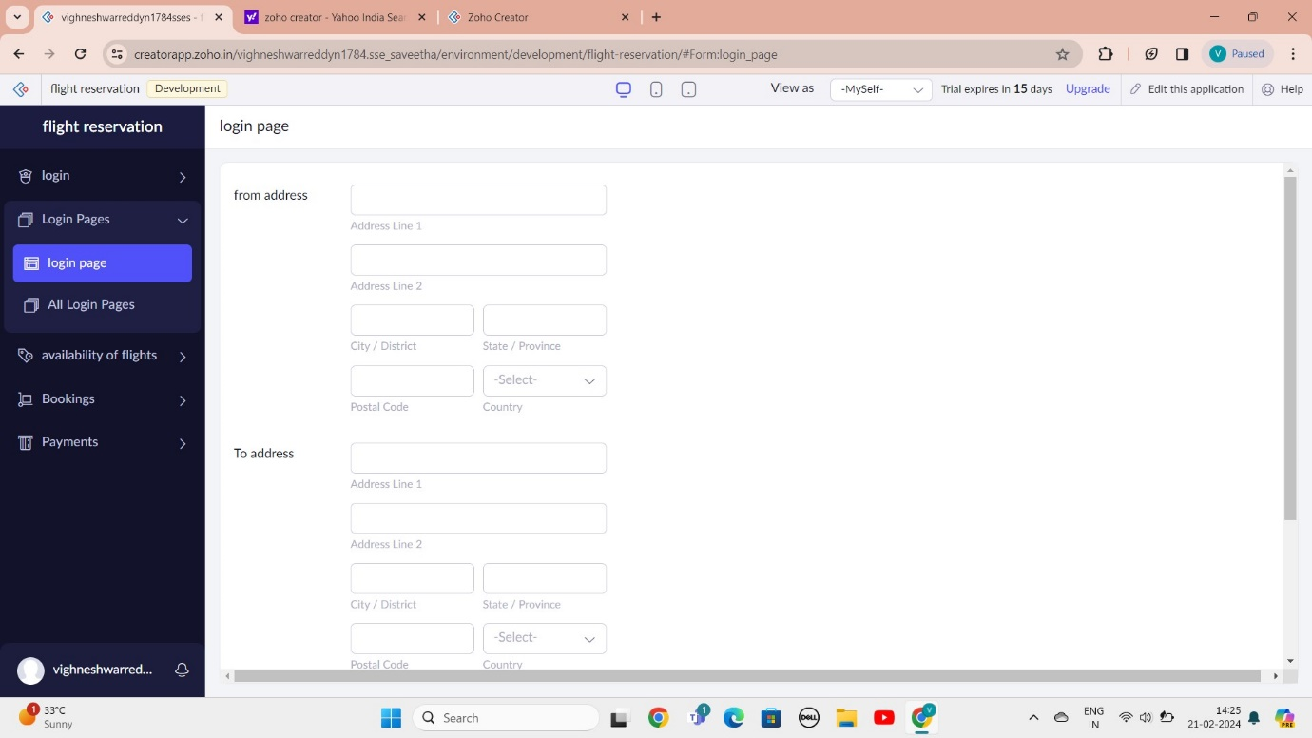

STEP 9: THE SOFTWARE AS BEEN CREATE AVAILABILITY OF FLIGHTS

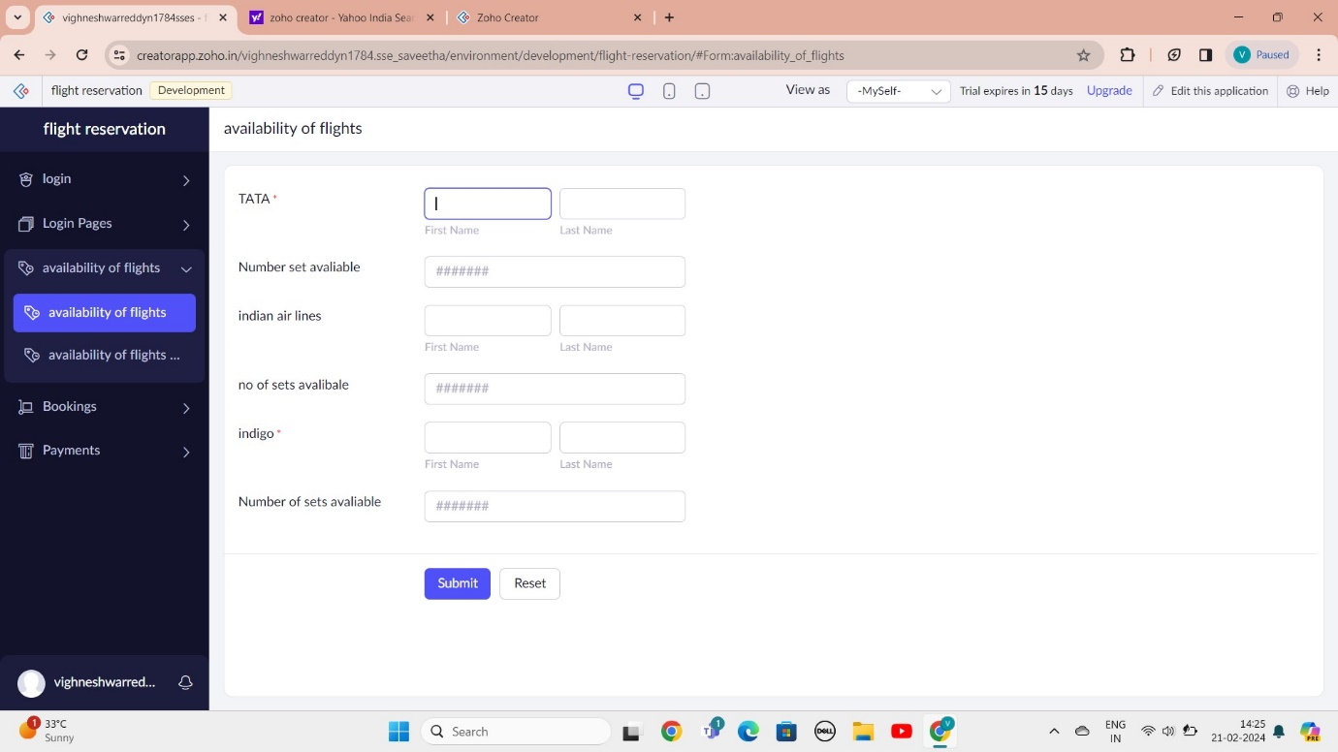

STEP 10: THE SOFTWARE AS BEEN CREATE BOOKINGS

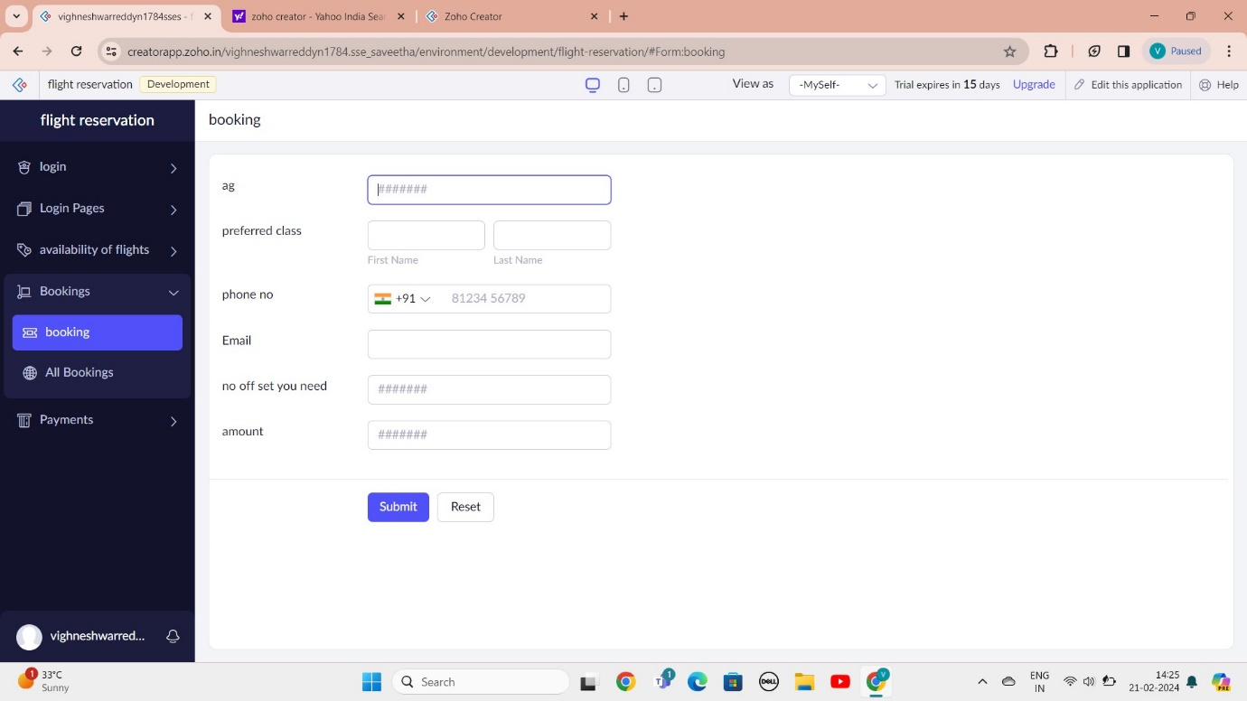

STEP 11: THE SOFTWARE AS BEEN CREATE PAYMENTS

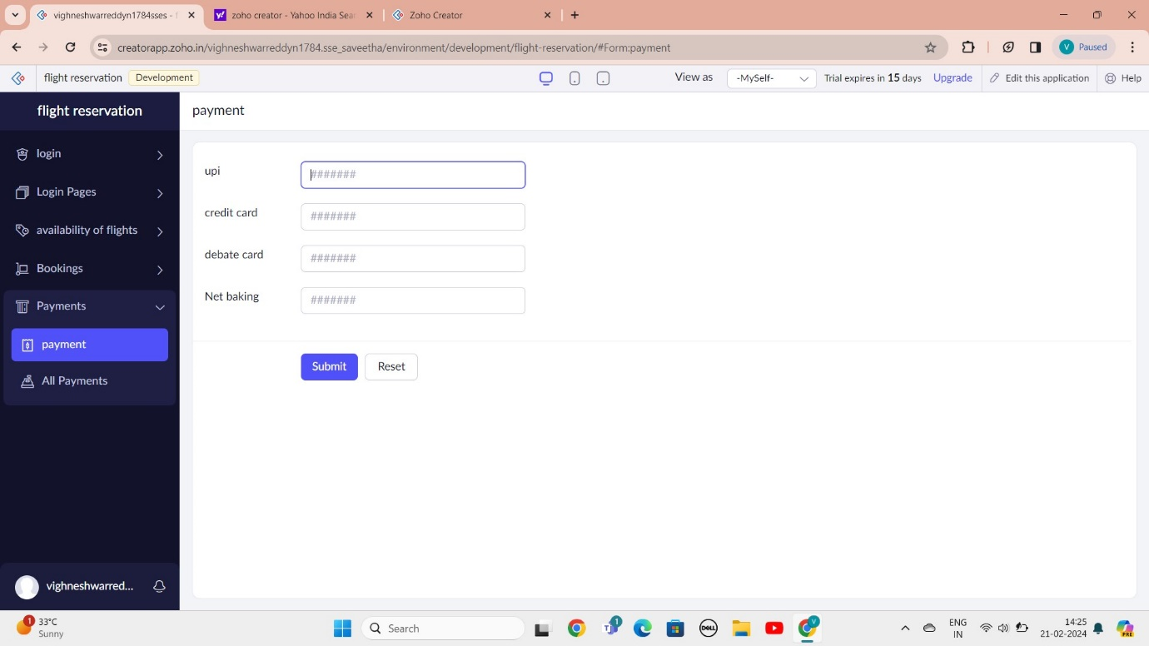

STEP 12: THE SOFTWARE AS BEEN CREATE

